Grade 7 Accelerated · Unit 4 · Lesson 5  Evaluating Expressions with Radicals  Question Bank 4.05 | Name______________________  Date______________________  Period____________________

Show your work. Circle your final answer.
For questions 1 through 6, evaluate.
1. 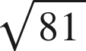

2. 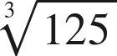

3. 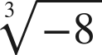

4. 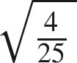

5. 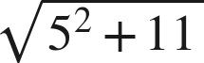

6. 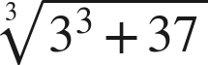

For questions 7 and 8, evaluate. Each expression has a power and a radical.
7. Evaluate each expression.
a. 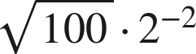

b. 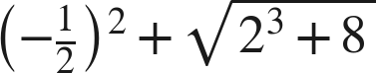

c. 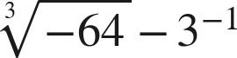

8. Evaluate each expression.
a. 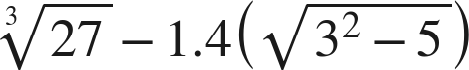

b. 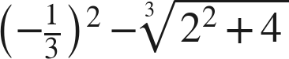

c. 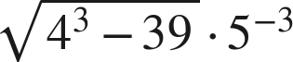

Working backwards.
9. Find the value of that makes each statement true. (The radicand is the unknown here, so it is not one of the listed perfect values until you find it.)
a. 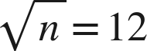

b. 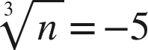

c. 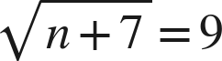

Reading someone else's work.
10. Tonya writes 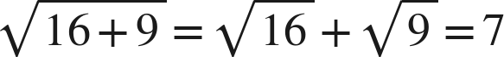. Evaluate the expression correctly, and explain in one sentence what the radical bar does that her method ignores.

11. Which is the value of 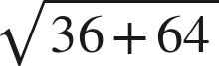 ?
○ A. 14
○ B. 100
○ C. 10
○ D. 50

12. Select ALL of the expressions whose value is 3.
□ A. 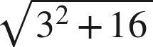
□ B. 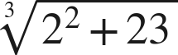
□ C. 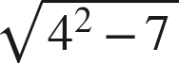
□ D. 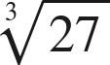
□ E. 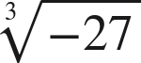
□ F. 